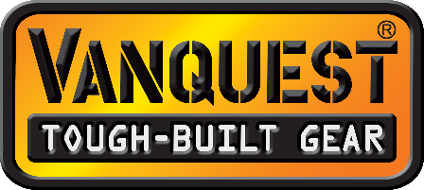
August 2019 Test & Evaluation Product List
The following products are available for test and evaluation (T&E) from Vanquest.
Please click on the links below to see more information available on our website.
** New for 2019 **
ENVOY-13 (Gen-4) Messenger Bag
ENVOY-17 (Gen-4) Messenger Bag
FATPack 4x6 First Aid/Trauma Pack (Red) *back in stock late August, other colors available
FATPack 5x8 First Aid/Trauma Pack (Red) *back in stock late August, other colors available
FATPack 7x10 First Aid/Trauma Pack (Red) *back in stock late August, other colors available
CACHE (Gen-3) RFID-Blocking Wallet
VAULT (Gen-3) RFID-Blocking Wallet
TRAVERSE (Gen-2) RFID-Blocking Passport/ID Holder
STICKY Panel 2x3
STICKY Panel 2x7
STICKY Cube: Expandable Storage Cubes Small Medium Large
FTIM-5x7 Gen-2 (Fast-Totally-Integrated-Maximizer) Organizer (Red)
FTIM-6x9 Gen-2 (Fast-Totally-Integrated-Maximizer) Organizer (Red)
** Current Models **
MARKHOR-45: 45-liter Backpack
IBEX-35: 35-liter Backpack
IBEX-26: 26-liter Backpack
KATARA-16: 16-liter Backpack (Convertible to Sling Pack)
SKYCAP-46: 46-liter Duffel Backpack
ELASTO Gear Locks
FALCONER-30: 30-Liter Backpack
RACKIT-36 (Gen-2) Covert Rifle Pack
HYDRA Bottle Holder
Vanquest 32oz Stainless Steel Insulated Water Bottle
EDCM 2.0 (Every Day Carry Maximizer) Slim / Husky / Huge
PPM 2.0 (Personal Pocket Maximizer) Slim / Husky / Huge
Reviewer Conditions:
- T&E Items valued over $100 MSRP must be returned* after T&E with the provided prepaid return label. Reviewer has the option to purchase the item at 25% off MSRP.
*Special conditions may be granted on case-by-case basis with Vanquest approval.
- T&E items valued under $100 MSRP may be kept after review or returned at reviewer’s discretion to Vanquest with included prepaid return label.

- All T&E products are sent with Product information / Specification sheets
- High Resolution product images available upon request.
For questions regarding products or Reviewer Program, please contact Alex Nunes at 949-216-8880 Ext. 501 or email vanquestteam@vanquest.com
About Vanquest:
In 2011, a team of outdoor gear designers and 2/3 original founding members of Maxpedition founded the Vanquest brand. Since then, Vanquest has been building ultra-durable bags and packs with the best quality and value to organize your everyday carry (EDC) gear. Vanquest products are used by professionals such as the US Secret Service, FBI and US Marshals. We have the experience to help you stay organized & prepared, every day! Search ‘Vanquest Gear’ on YouTube to find hundreds of product reviews. www.VANQUEST.com
Vanquest Evolves Gear for 2019
Upgraded Backpacks, Pouches & New Accessories
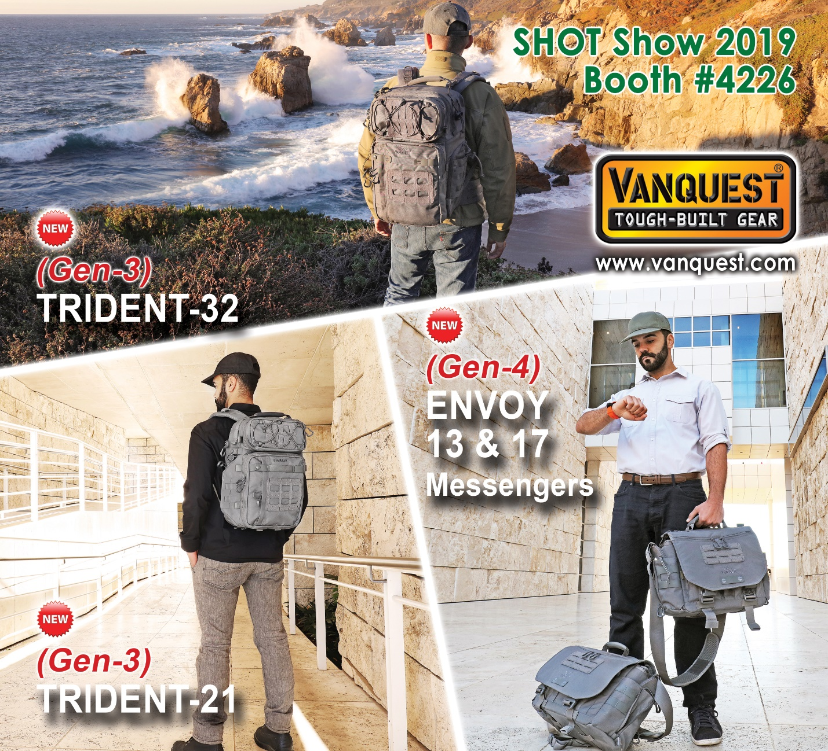
Las Vegas, NV: Vanquest announces updated TRIDENT backpacks, expanded ENVOY messenger bags, new STICKY CUBE’s, and First Responder Red FATPack’s & FTIM Maximizers at SHOT Show 2019.
Following our continuous evolution, the TRIDENT-21 (Gen-3) and TRIDENT-32 (Gen-3) backpacks now feature a low profile, less-tactical appearance. With collapsible side bottle pocket (new for TRIDENT-21), new user-configurable dividers and improved shoulder suspension system with vented back panel for more comfortable carry.
This year Vanquest has expanded the popular ENVOY messenger bag series into two offerings: the ENVOY-17 for your mobile workstation and the ENVOY-13 for your compact EDC gear. Both models also feature low profile, less-tactical appearance, a Hi-Vis fully loop-lined main compartment compatible with new configurable dividers. There’s also enhanced access to rear CCW compartment for faster deployment.
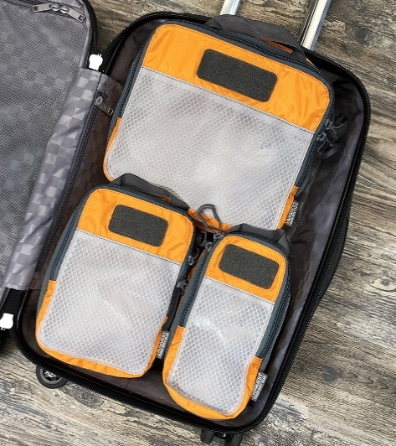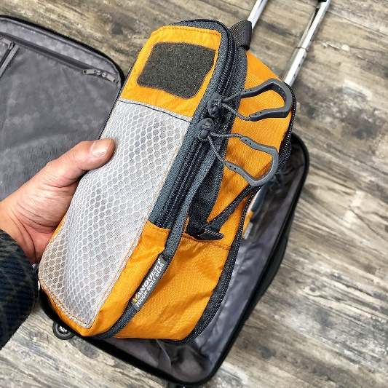
New for 2019 is the expandable STICKY CUBE, available in three sizes (S/M/L) to optimize space while organizing your gear. These strong & lightweight packing cubes expand or compress to fit your needs with hook-backing for attachment to any loop-surface. Breathable and translucent ToughMesh window lets you ID contents inside.
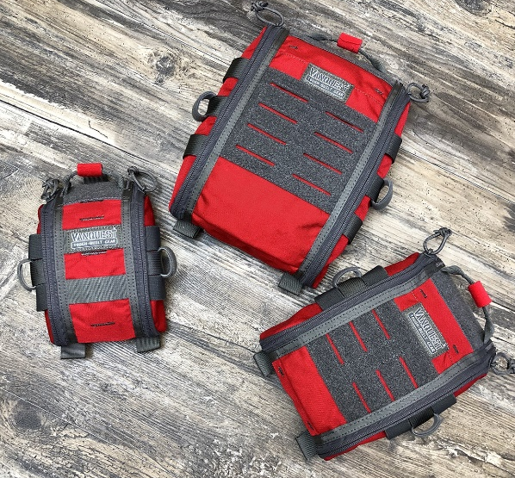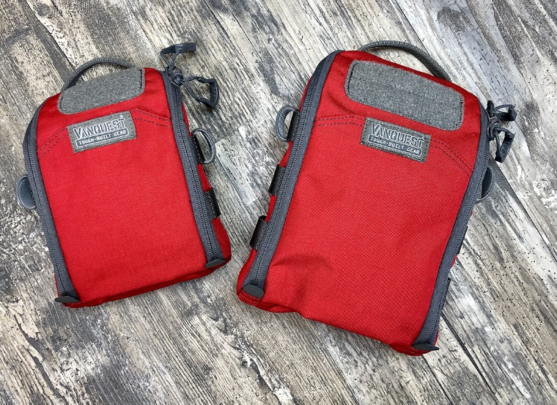
Following customer demand, the renowned FATPack medical pouch series (4x6, 5x8 & 7x10) and FTIM Maximizers (5x7 & 6x9) are now available in First Responder Red for instant identification of life-saving gear.
About Vanquest®:
In 2011, a team of outdoor gear designers and 2/3 original founding members of Maxpedition® founded the Vanquest® brand. Since then, Vanquest has been building ultra-durable bags and packs with the best quality and value to organize your everyday carry (EDC) gear. Vanquest products are used by professionals such as the US Secret Service, FBI and US Marshals. We have the experience to help you stay organized & prepared, every day! Search ‘Vanquest Gear’ on YouTube to find hundreds of product reviews. www.VANQUEST.com

